|  |
| --- |
| Ertuğrul Yolcu 2305779  Ece Irem Yazir  Musa Ulusoy |
|  |
|  |

|  |
| --- |
| EE464 HARDWARE PROJECT |
| Final Report |
| Formlar ve Görseller | ODTÜ ELEKTRİK - ELEKTRONİK MÜHENDİSLİĞİ |

Table of Contents

Intro 2

Topology Selection 2

CONTROLLER DESIGN 4

SNUBBER DESIGN 7

TRANSFORMER DESIGN 9

IMPLEMENTATION 12

Line Regulation 15

Load Regulation 16

LOSSES 17

Copper Losses 17

Core Loss 17

COMPONENT CALCULATIONS 17

Output Capacitor 18

Diode and Switch 18

Feedback and Reference Resistances 19

SIMULATION RESULTS AND COMPONENT SELECTION 20

IMPLEMENTATION RESULTS 24

THERMAL CALCULATIONS 24

Mosfet 24

Diode 25

CONCLUSION 25

REFERENCES 25

# Intro

This project is based on the need for an isolated DC-DC converter that takes an input voltage from 24V to 48V and gives a constant output of 15V at 45W with closed-loop control. The chosen converter design’s both lines, and load regulations, as well as the output voltage ripple, needs to be 3%. This design report will focus on the topology and its component selections due to these constraints. Analytical calculations for electrical and magnetic design and overall simulation results will be discussed.

Table 1 Project Constrains

|  |  |
| --- | --- |
| Input Voltage Range | 24-48V |
| Output Voltage | 15V |
| Output Power | 45W |
| Line Regulation Percentage | 3% |
| Load Regulation Percentage | 3% |
| Output P-P Voltage Ripple | 3% |

# Topology Selection

The forward converter is also simple like flyback but instead of storing the energy the transformer delivers the power via it. The output current is relatively more stable than some other isolated topologies but the output inductor and other semiconductor devices highly affect the power loss, heating and cost in our design. Also, this topology is very sensitive about load changes and commonly used in high current applications, so in order to protect our load regulation constraints and since our project is not in high output current range, we did not choose to use this topology.

Push-pull and half/full bridge topologies were considered since the core utilization is better and copper losses are less in these topologies, but these topologies are more applicable to high output power applications. Also, for a small scaled project like ours did not need more components, hard switch control and high switch stresses, so, this is not the best option for us.

In this project, fundamental flyback topology is chosen. Flyback converters are used mostly in low to medium power applications, so this was the main reason why we tend to choose this topology. Also, this topology is chosen due to its simplicity in construct and control, especially in discontinuous conduction mode. It has a smaller number of circuit elements (mainly passive elements); also, no energy storage inductor is needed because of the transformer, and only one diode is used in the topology, which causes less loss in the system. Also, there are more minor EMI problems with respect to other isolated topologies.

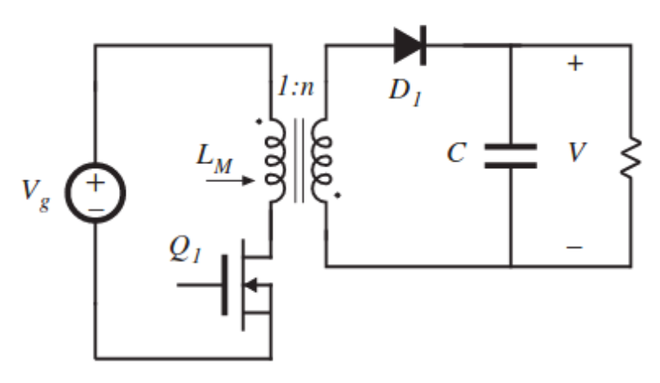

Figure 1 Flyback Converter Topology

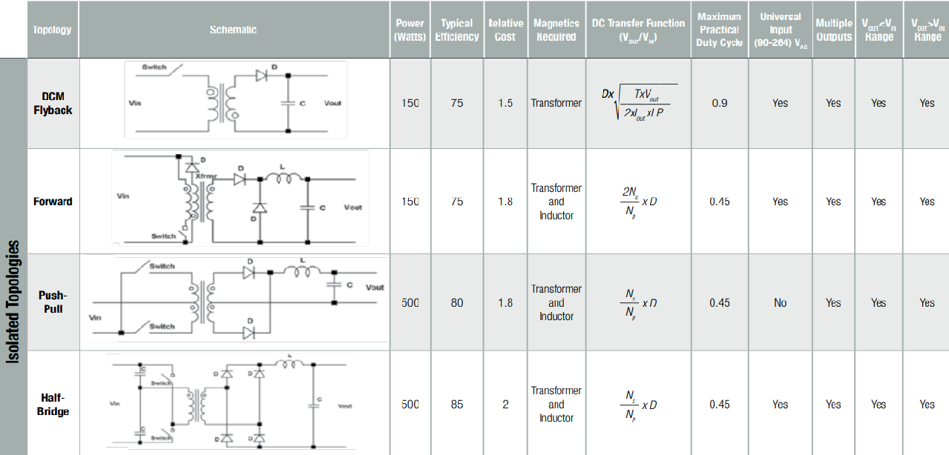

Figure 2 Isolated Converter Topologies Comparison (retrieved from Würth Elektronik)

# CONTROLLER DESIGN

There are different kinds of controllers we have found and implemented in LTspice. The first one is LT3751 which is a capacitor charger. The main advantage of the controller has UVLO/OVLO pins that are used for selecting the input voltage range. Another advantage of the controller is that two resistors which are RVout and RBG, are used to set up the output voltage.

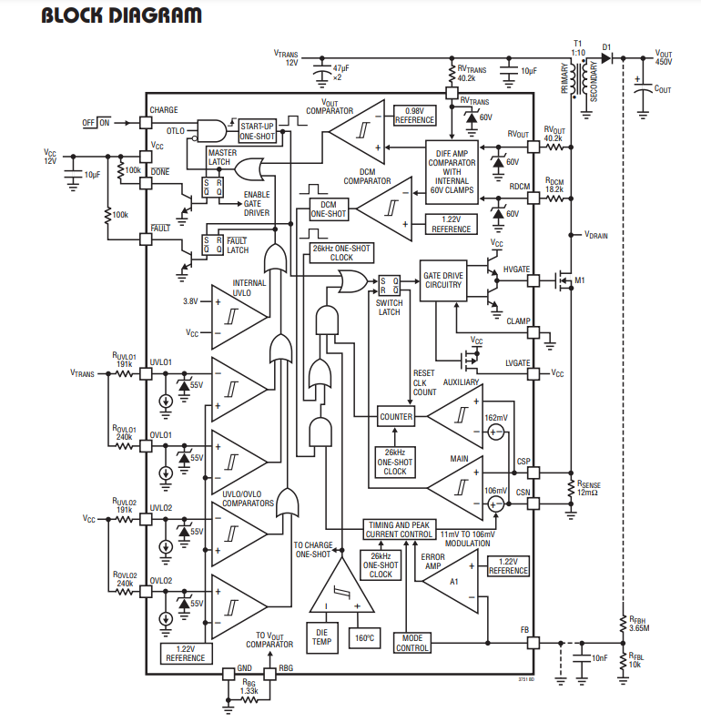

Figure 3 Block diagram of the LT3751

Also, this controller has the ability to operate in DCM operation, which increases the efficiency of the converter, which is really critical for the project. At that point, most of the requirements for the project are satisfied, whereas this controller is used for the capacitor charger, emphasized at the beginning. Because of that, when this controller was used with the load which is 5Ω in this project, the output voltage decreased to zero. In these controller applications, output voltage regulation resistors exist for high output values. On the other hand, we are trying to regulate the voltage at the 15V and 45W output. In this step, we could not reach the required voltage level because of the step size of the controller. The reason behind this is the controller, which is LT3751, is created for high voltage values. The digital voltage step size of the controller is higher than 15V.

After this controller, a lot of different kinds of controllers are implemented in LTspice and Simulink. Unfortunately, most of them could not reach the requirements that are specified in the project description. After the search step, we have found the LT3748, which is created by Linear technology. LT3748 is the isolated flyback converter controller. The advantages of this controller can be listed as:

-Wide input range and controllable lower threshold

-No transformer third winding or opto-isolator required for regulation

-Primary side winding feedback load regulation

-The LT3748 has different kinds of advantages besides those. The regulated output voltage can be decided as with the formula:

-Another advantage of the controller is indicating the inductance limitations which are upper and lower bounds for the transformer design. This part will be explained in the transformer design step.

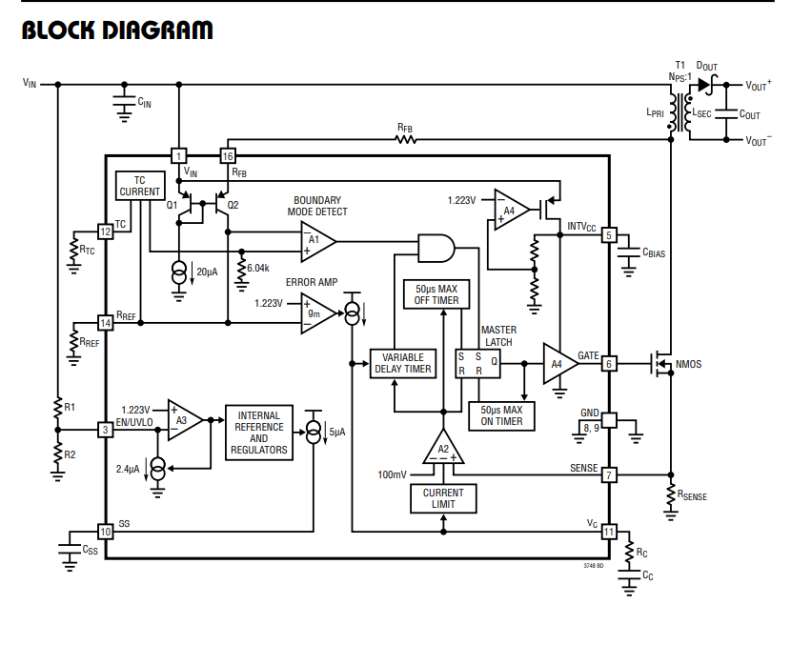

Figure 4 Block diagram of the LT3748

The manufacturer of this controller which is Analog Devices, has created the LTspice models for this chip. Thanks to that, we have implemented the schematic of the flyback converter with LT3748.

Another chosen controller is LM51561 which is created by Texas Instruments. This controller is the second option for us. The advantages of this controller are wide and controllable input range, controllable output voltage, small size and low cost, and constant peak current limiting over input. The features of the LM51561 are similar to the LT3748. Both of them are ordered and the applications will be started with the LT3748.

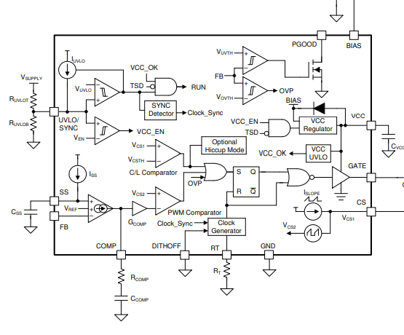

Figure 5 Block diagram of the LM56511

Our last option for the controller is using STM32 or Arduino to control the converter. At this point, the controller was designed to change the DON and Doff time.

# SNUBBER DESIGN

The voltage increase at the drain side of the MOSFET, when the switch is off, appearing because of the leakage inductance of the transformer. When the current at the input side is high enough, more stored energy needs to be dissipated. Because of that, leakage inductances of the transformer need to be minimized. Considering the inadequacy or failure of the snubber circuitry, the VDS voltage rating of the MOSFET can be chosen with the safety margin. There are different kinds of snubber circuit designs that exist. One of the popular ones is the RCD snubber circuit. Another one is the Zener snubber circuit. The advantage of the Zener suppressing circuit is dissipating the power when the voltage reaches the dangerous voltage level for the MOSFET.

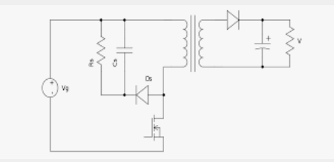

Figure 6 RCD Snubber circuitry

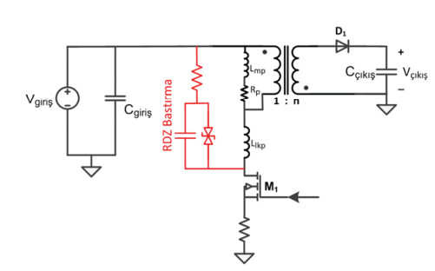

Figure 7 Snubber Circuit with Zener Diode

The advised approach for designing the snubber circuitry is measuring the period of the ringing when the switch is off without snubber circuitry. After that, the snubber capacitor needs to be added to the circuit starting from the feasible capacitance like 100pF. When the damping period reaches 1.5 -2 times longer, the capacitor is chosen. The change in period can determine the value of the parasitic capacitance, and the initial period of the damping can determine the leakage inductance. In addition to that, those values can be determined from the leakage inductance of the transformer and switch capacitance. When this inductance and capacitance value is determined, the resistance of the snubber needs to be decided.

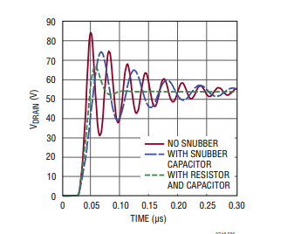

Figure 8 Effect of the Snubber taken from the Datasheet of the LT3748

Dissipated power will be equal to:

# TRANSFORMER DESIGN

For the transformer design, the start point was the controller’s limitations. According to the chosen IC LT3748, primary inductance has the following limitations:

The gain formula of the flyback converter is So, for the max Vin, D=0.27. For the min Vin, D=0.43. The operating frequency is chosen as 80 kHz. Hence, ton(min)=Dmin/f­sw=3.37 µs.

So .

LPRI is chosen as 55 µH inside these constraints. After this step, the core was chosen by the following step:

.

According to these, the most suitable core was KOOL MU 00K3515E090 since it has the lowest multiplication. Then, turn numbers found with the parameters of this core:

After finding the turns number, by using the RMS values of the primary and secondary side currents, cable selection was made:

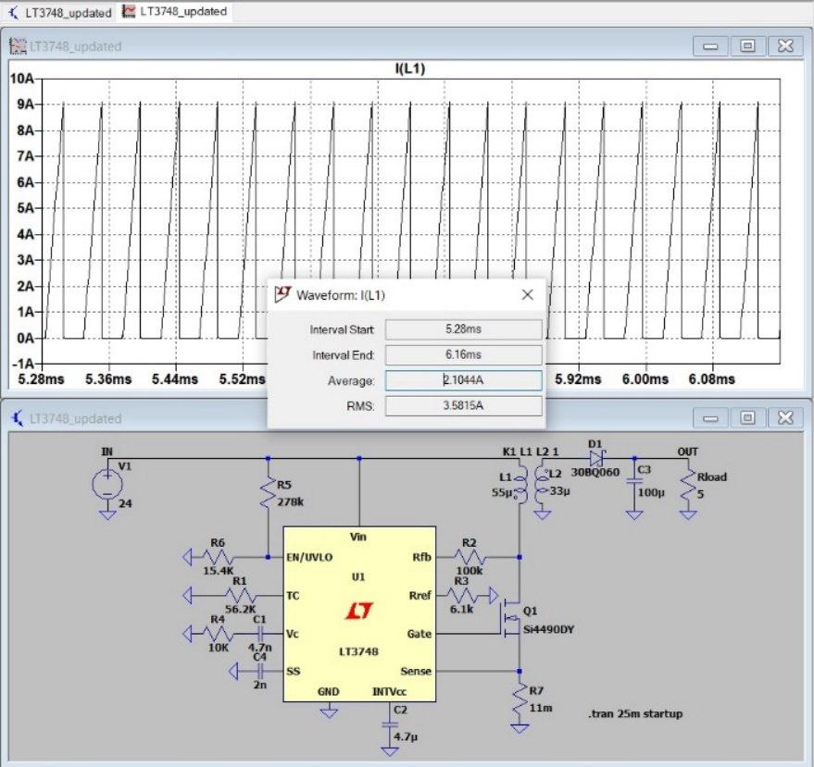

Figure 9 Primary side rms current

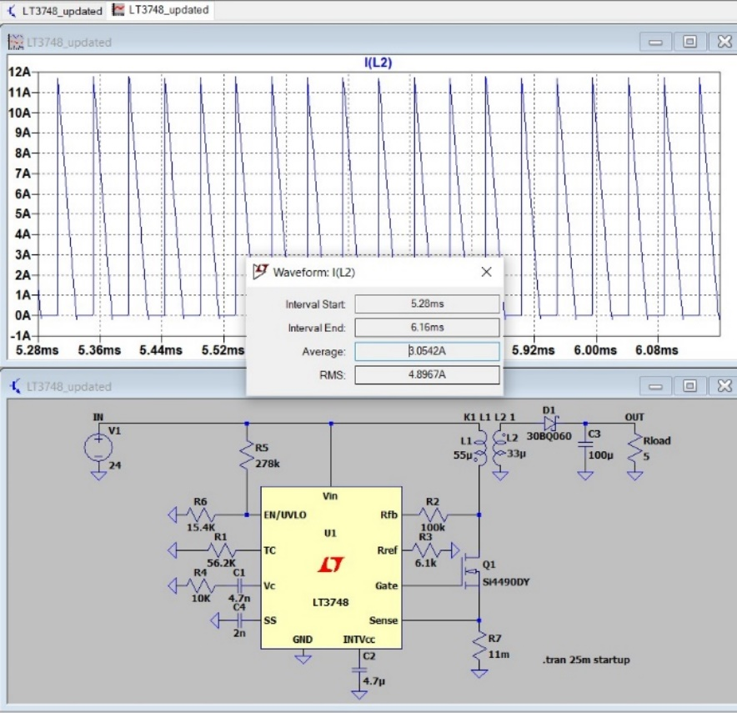

Figure 10 Secondary side RMS current

According to the simulations, the primary side voltage is a maximum 3.6 A. Secondary side voltage is a maximum 4.8 A. For a safety margin, the primary side current was chosen as 4A, and the secondary side voltage was chosen as 5A.

* For the primary side:
* For the secondary side:

For the cable selection, AWG 26 cable was chosen due to the high operating frequency margin. However, in the lab, there was AWG 25 cable with 0.162 mm2 cross-section area and %100 skin depth at 85 kHz. Hence, we carried on with this cable.

* For the primary side:
* For the secondary side:

After we implemented the cables in the lab, they did not fit into the selected core. In real life, it showed us with these cable selections and turns number, the fill factor must be higher than 1. So, the core selection is changed again.

After we searched the core inventory, the most suitable core was ferrite 0P44022EC core since, due to its material, leakage would be much less than the kool mu core. Also, its cross-section and window area is large enough to fit the cables. Then, all the calculations were made for this core. For the turn number, Al value of the core is important. So, if we change the A­l value of the core by adding an air gap to the core, we can acquire the desired turn numbers.

* Let’s assume the turn numbers as Npri = 12, Nsec = 9.5
* So,

So, by adding this air gap to the core, we can obtain the required reluctance value. If we calculate the magnetic flux density as

Hence, by this calculation, we can see that core is not saturated. It is not the expected value since we did all the calculations for B= 0.2 T. However, this result is close enough to the expected value, and it does not saturate the core. After that, the fill factor is calculated as follows:

It can be deducted that the fill factor is very small, and it shows that the core is overdesigned for this situation. However, since we built the transformer by hand, the fill factor is not high enough.

# IMPLEMENTATION

The transformer was implemented according to calculations. However, as expected, real-life and theoretical calculations did not match exactly. After implementing the transformer, we did the measurements.

Figure 11 Primary side inductance

For the primary side inductance measurement, which is magnetizing inductance, we left open the secondary side and connected the probes of the LCR meter to the primary side. The result of the measurement can be seen in Fig.11. The expected value was 55 µH, but it was measured as 53 µH. It is very close to the expected value.

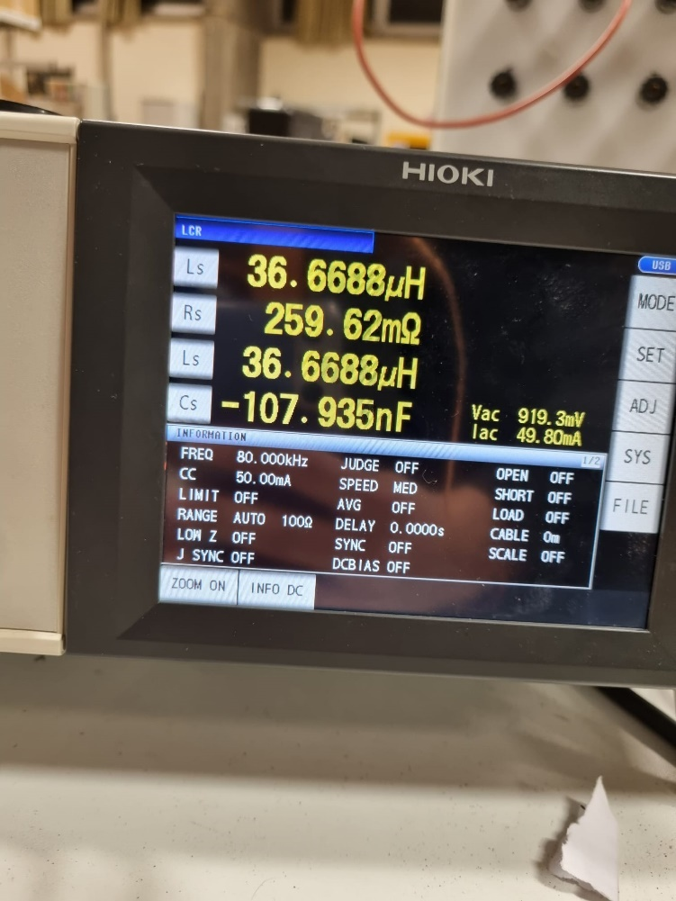

Figure 12 Secondary side inductance

For the secondary side inductance measurement, we left open the primary side and connected the probes of the LCR meter to the secondary side. The result of the measurement can be seen in Figure 12. It was measured as 36 µH.

If the turns ratio is checked by the inductance values, the turns ratio can be found as

So, the turns ratio is satisfied by the inductance values.

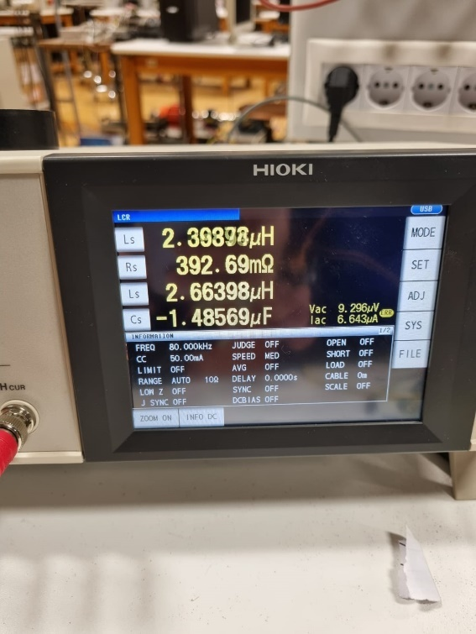

Figure 13 Leakage inductance value

For the leakage inductance, we shorted the secondary side and connected the probes to the primary side. The connection can be seen in Figure 14. Since it was thought that we might change the turns in the future, excess cables did not cut out. Hence, resulted in more leakage inductance of 2.6 µH, which can be seen in Figure 13.

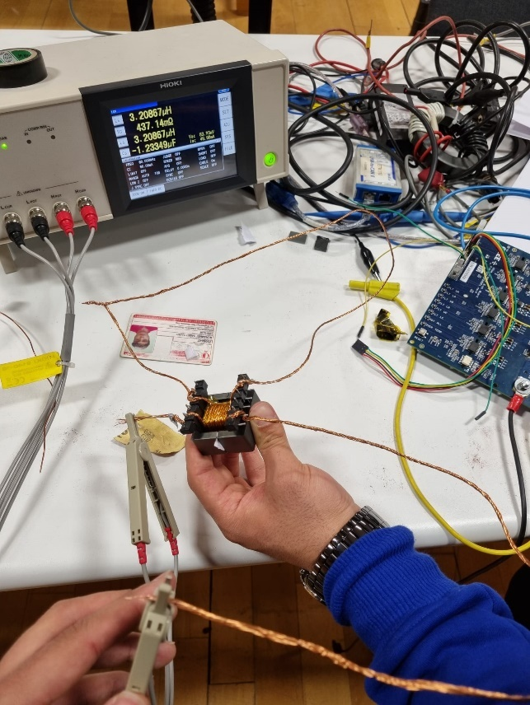

Figure 14 Leakage inductance measurement

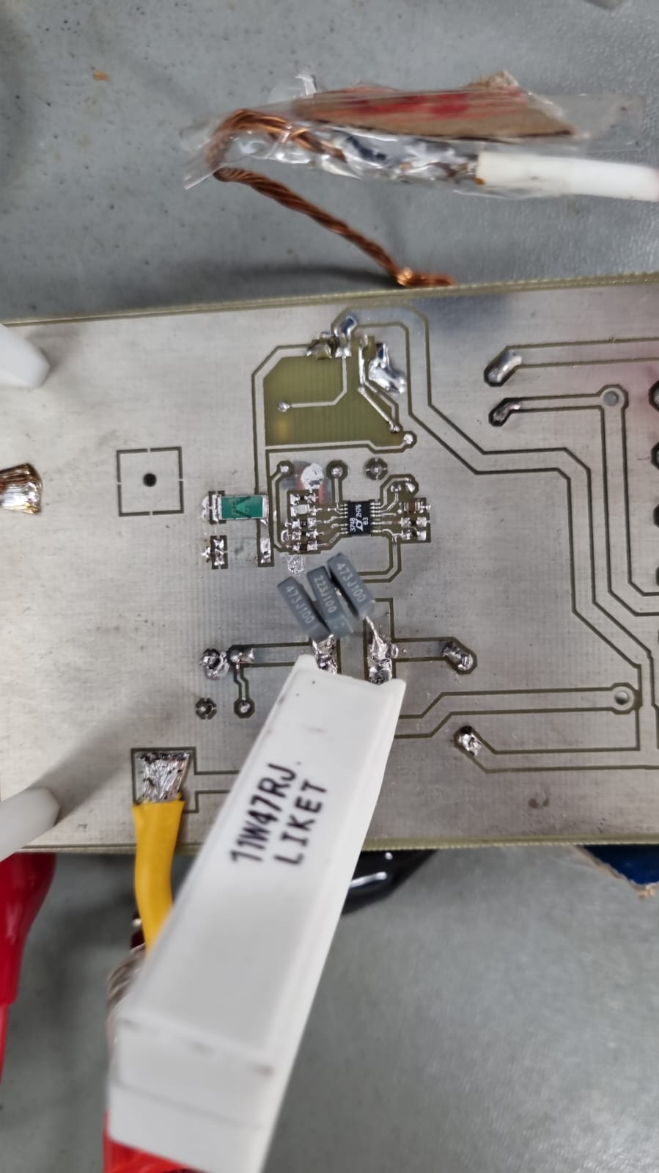



In the figure above, you can see the controller (red circle) and the RCD snubber (blue circle). It was hard to implement controller into the pcb since its size was extremely small and the components connected to the controller where 402 packet. Snubber is designed to dissipate the power stacked on the MOSFET. In order to do that, 11 nF ceramic capacitor and 40 ohm sand stone resistance. Initially, we implemented through hole 0.125 W resistor by paralleling 8 of them. However, in our first design, they burn out. Hence, we find the solution in paralleling three 120 ohm, 11 W sand stone resistors. We paralleled three of them to make a safety margin and dissipate more heat with more area.

## Line Regulation

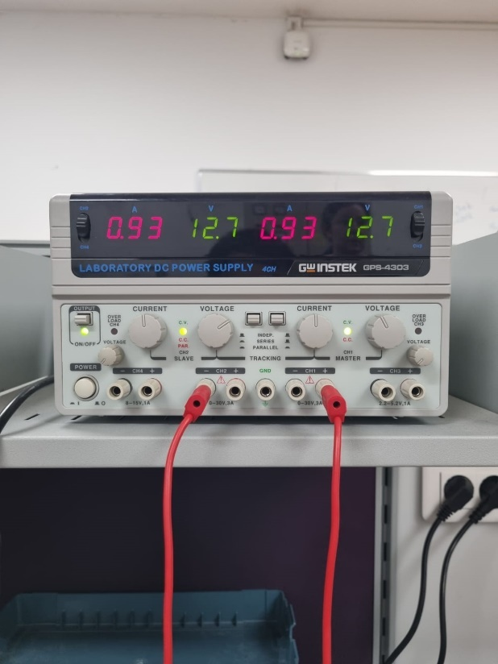

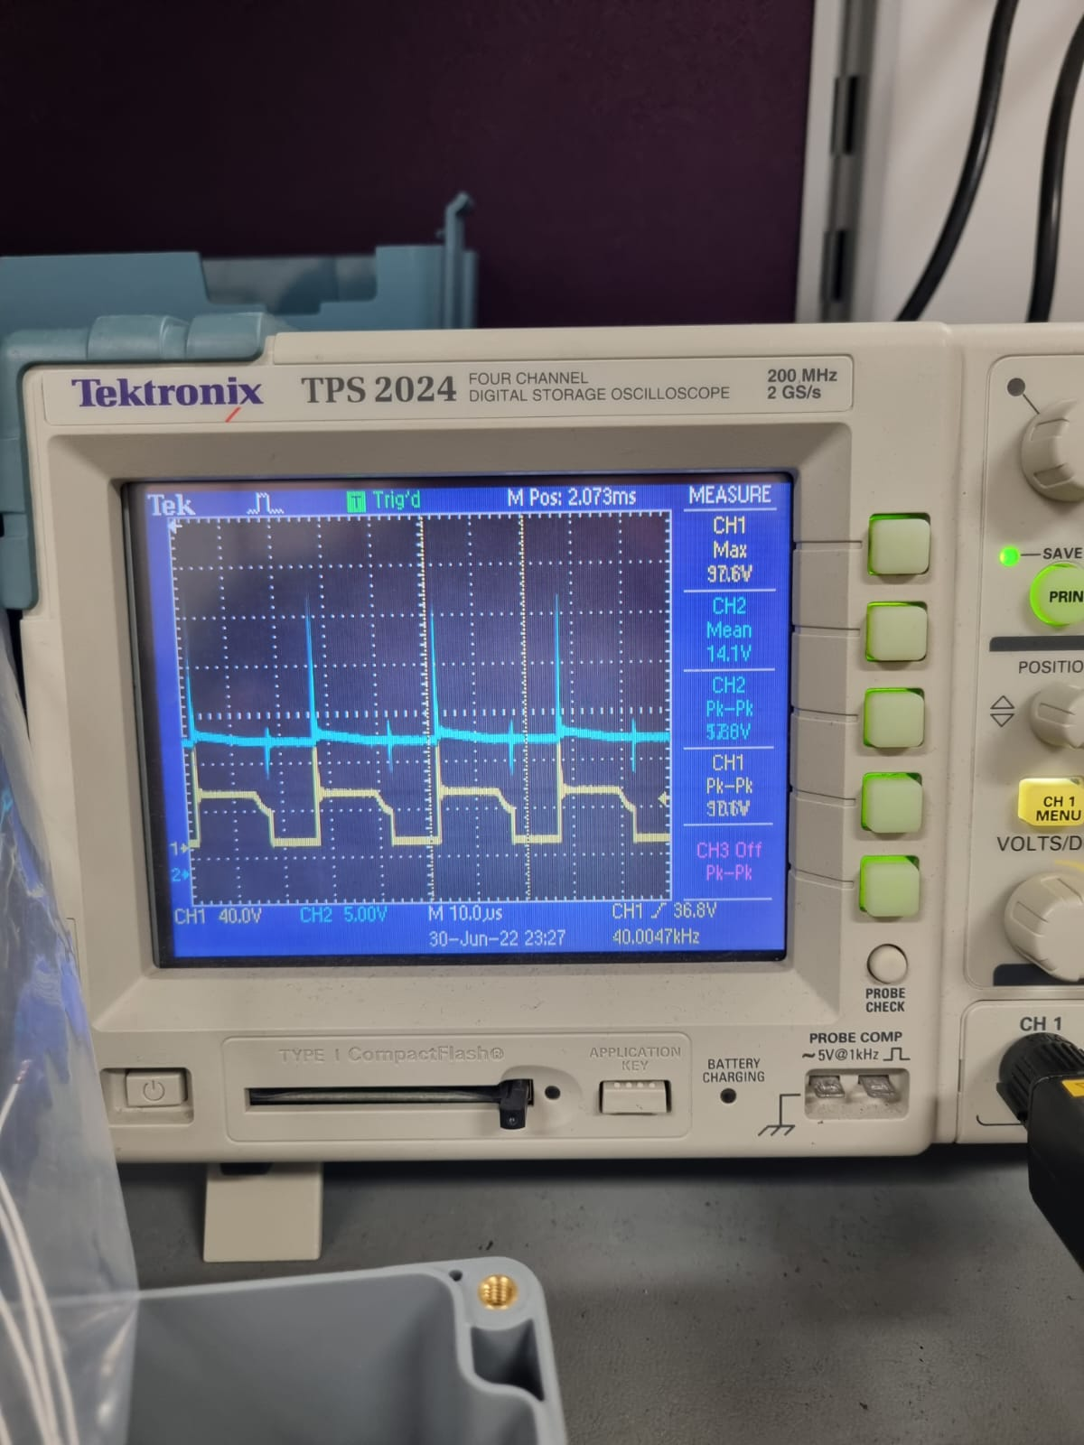

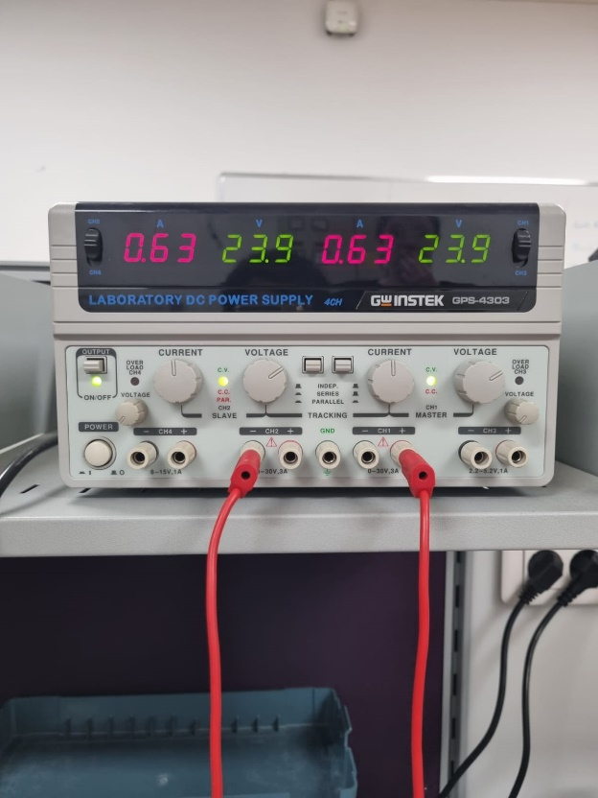 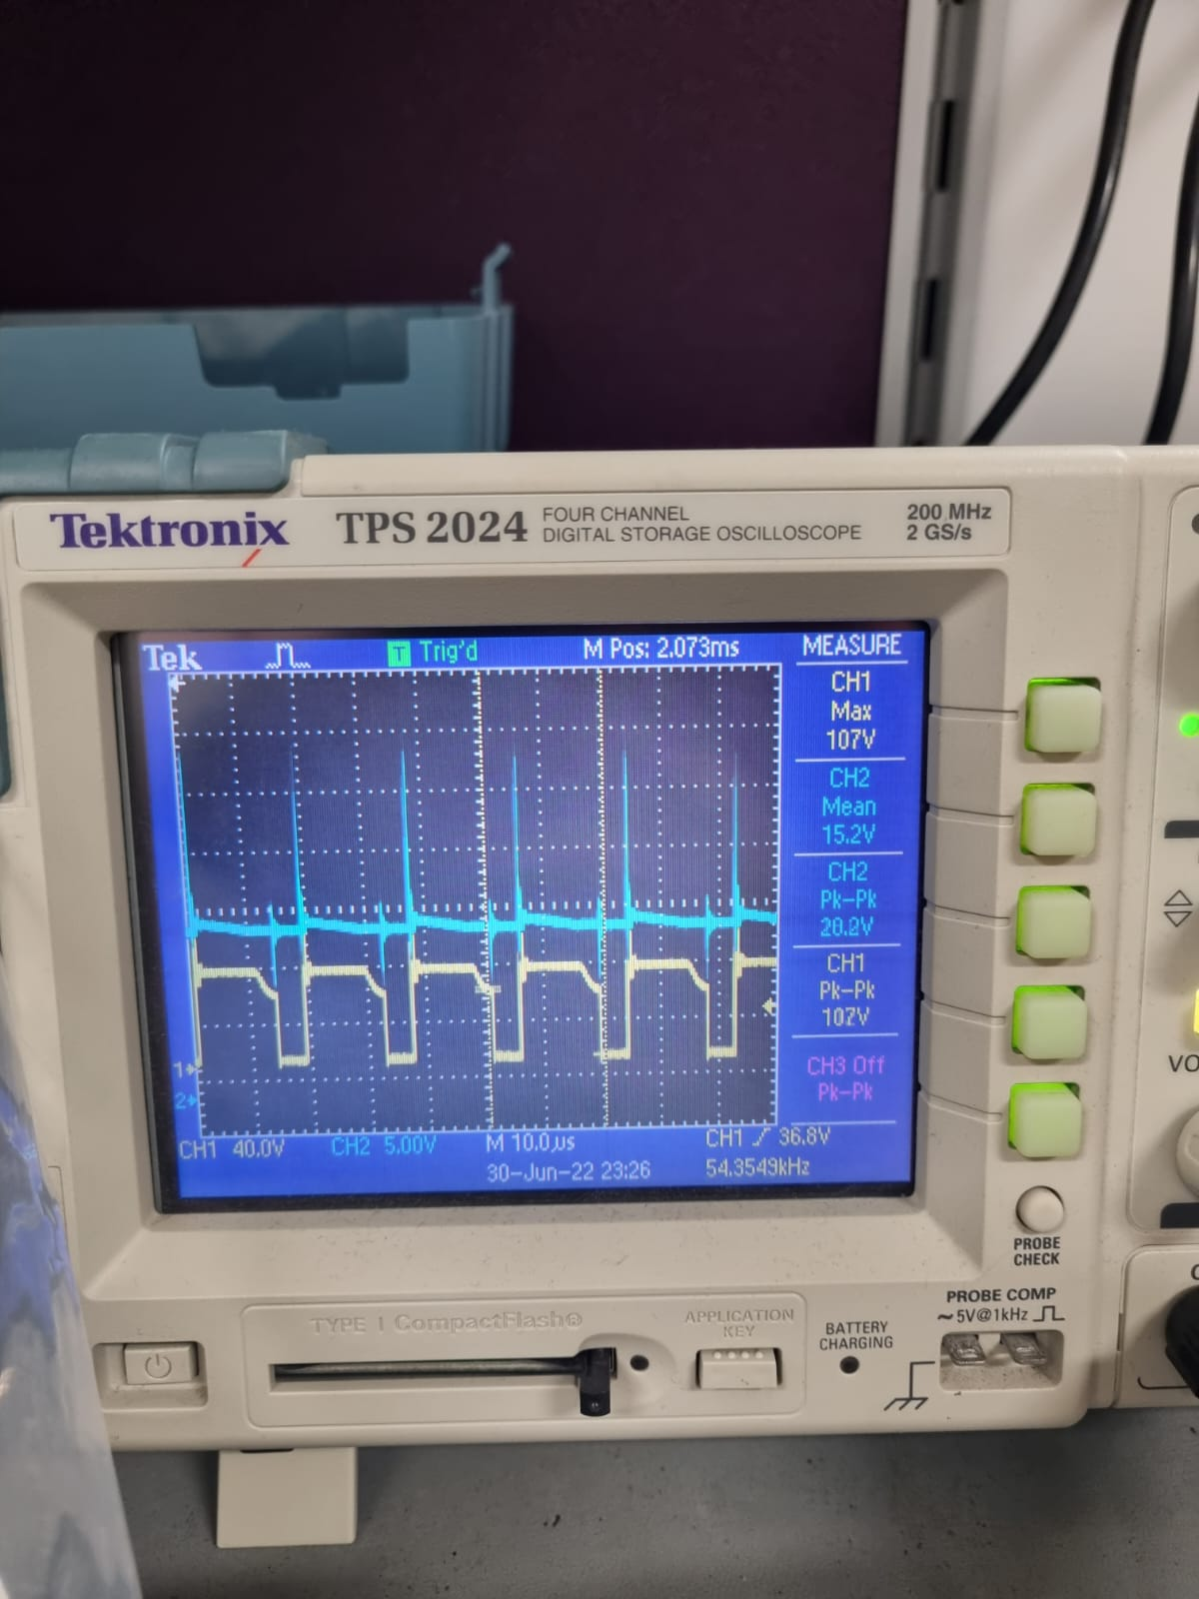

In the cases above, we’ve measured the line regulation while channel 1 gives the VDS voltage of the MOSFET and channel 2 gives the output. In order to do this, we’ve set our output voltage to 15 V by changing the load when the input voltage is 32 V. Then, we initially decreased our input voltage to 24 V and measured the output voltage. The output voltage was 14.1 V as you can observe from the figure XX above. After this, we’ve set our input voltage to 48 V and measured the output voltage. The output voltage vas 15.2 as you can observe from the figure XX above. So, if the line regulation is calculated:

This is higher than the required line regulation. The reason behind this can be the leakage inductance in the transformer. Due to the leakage inductance, controller cannot sense fully accurate current in the primary side, and cannot adapt the switching frequency and duty cycle appropriately.

## Load Regulation

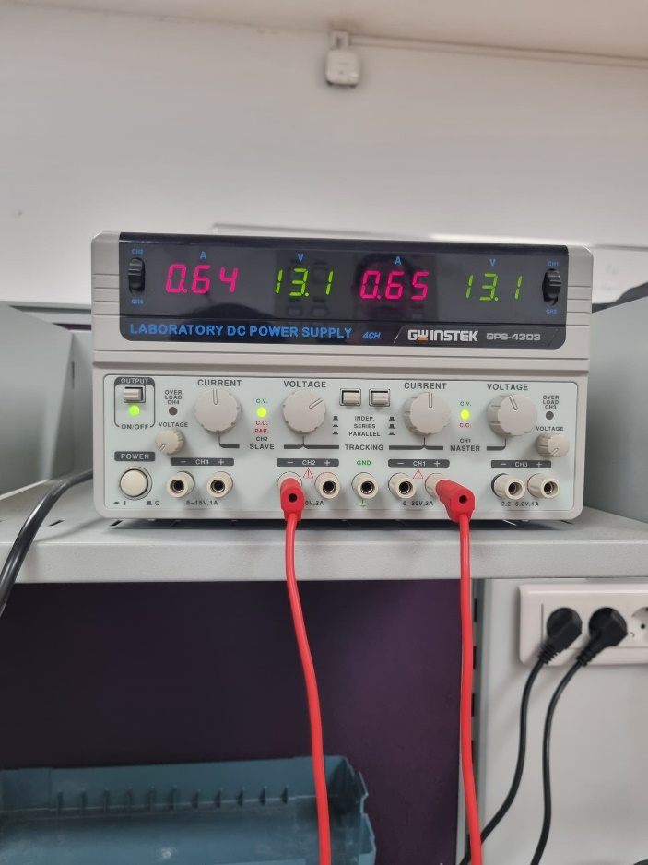

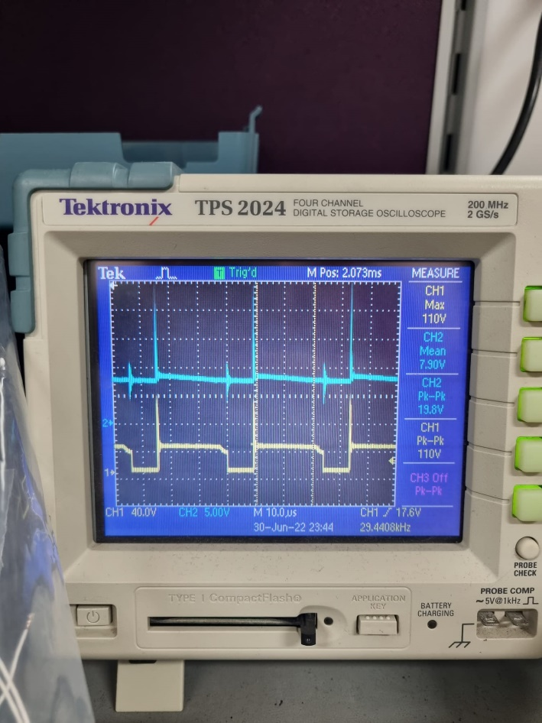

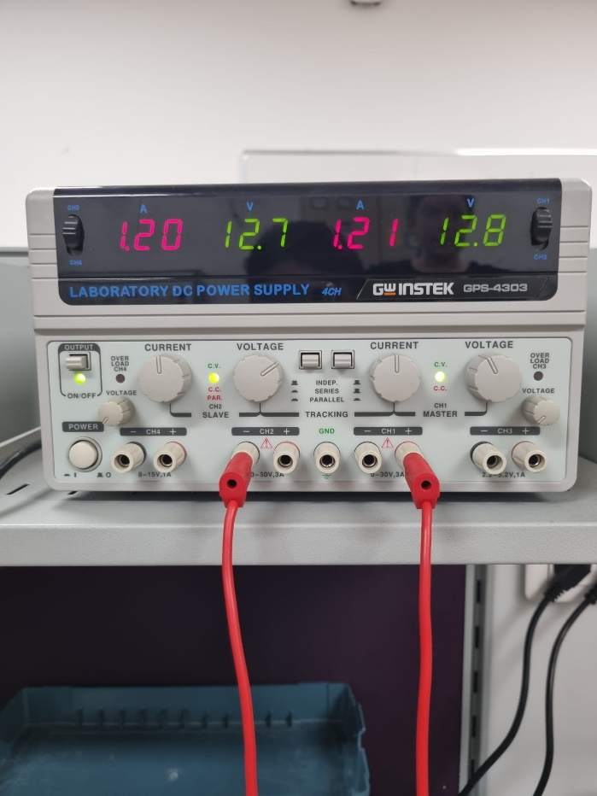

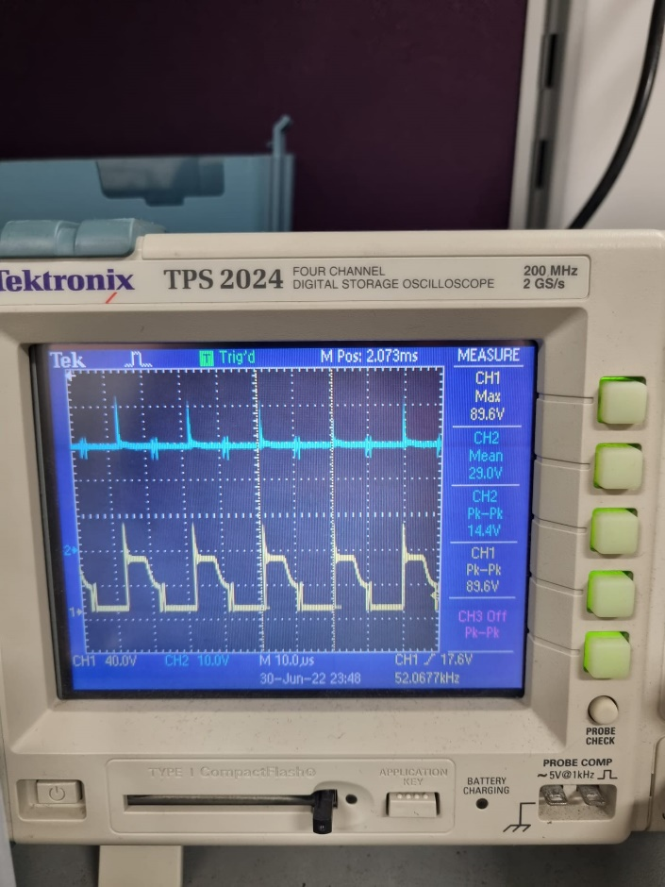

In the cases above, we’ve measured the load regulation while channel 1 gives the VDS voltage of the MOSFET and channel 2 gives the output. In order to do this, we’ve set our input voltage to 24 V and changed the load from 5 ohm to 50 ohm. In the figure XX and XX, results of the 5 ohm load case can be seen. The output voltage is approximately 8 V. On the other hand, in the figure xx and xx, results of the 50 ohm load case can be seen. The output voltage is 29 V. So, if the load regulation is calculated:

# THEORETICAL LOSSES

### Copper Losses

For the copper losses, we need to find how much cable is used. To obtain this information, dimensions of the core must be known

Figure 15 Dimensions of the core

Dimensions of the core are represented in the figure above. According to this figure,

### Core Loss

According to the core loss per cm3 value of the core, approximate core loss is calculated as follows:

Since we are operating at high frequencies, core losses are much higher than the copper losses, and it is expected.

# EFFICIENCY

Efficiency is calculated when the load is 5 ohm and the input voltage is approximately 24 V. In these conditions, efficiency is

According to this calculation, design has 4.3 Watts of loss. These losses are mostly due to the magnetic and copper losses calculated in the theoretical losses section, and due to the snubber designed for the MOSFET.

# COMPONENT CALCULATIONS

## Output Capacitor

From the voltage gain expression of the flyback converter, our duty cycle becomes

= N21 * where N12 is chosen as 1.23

So, the duty limits become 0.44 for 24V input and 0.28 for 48V input.

= 0.03

D/(0.03*5*80kHz) = Co

Co has to be at least 36.7 µF (For 24 V input voltage) from the converter equations.

On the other hand, from the LT3748 datasheet output capacitor can be specified as

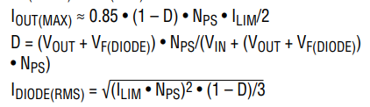

Figure 16 Output Voltage Equation with respect to Limiting Current

ILIM = = 8.62A (Duty approximated as 0.37)

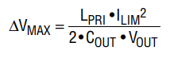

Figure 17 Output Capacitor Equation from the LT3748 Datasheet

0.03*15 =

**Co = 302.72 µF**

## Diode and Switch



Figure 18 Diode RMS Current Equation from the Datasheet

ID(RMS) == 4.86A

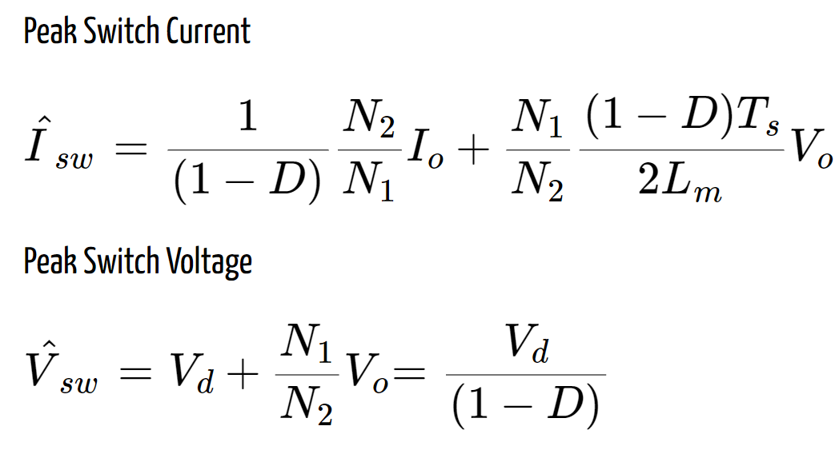

Figure 19 Peak Values for Switch

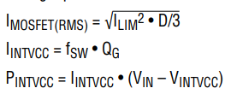

Figure 20 MOSFET RMS Current Equation from the Datasheet

IMOS(RMS) = = 3.03A

Vsw(max) = 48/(1-0.28) = 66.7V

Isw(max) = 3/0.8856+ 5.6 ≈ 12.07A (where Lm is 55 µH)

## Feedback and Reference Resistances

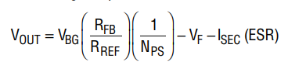

Figure 21 Output voltage equation from the datasheet

Where VBG bandgap voltage for a silicon switch is around 1.2 V,

NPS = N1/N2 = 1.23,

the forward voltage drop of the diode is 0.64V,

Equivalent series resistance on the secondary side is //ωL2//Ro ≈ 0

= 16.03

So, when RREF is given as 6.1kΩ (limited in the datasheet) RFB becomes around 97kΩ.

# SIMULATION RESULTS AND COMPONENT SELECTION

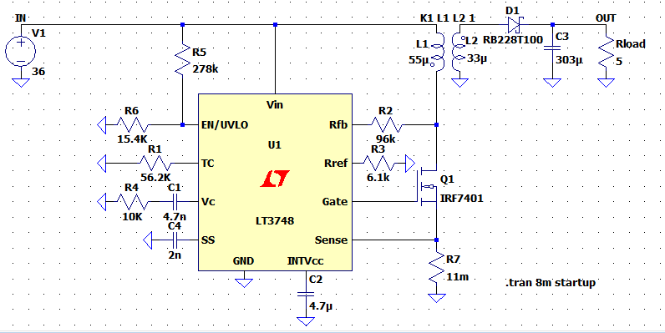

Figure 22 Circuit Diagram for the overall design with LT3748

Due to the above calculations in the previous section, the simulation circuit has been set, as seen in Figure 22.

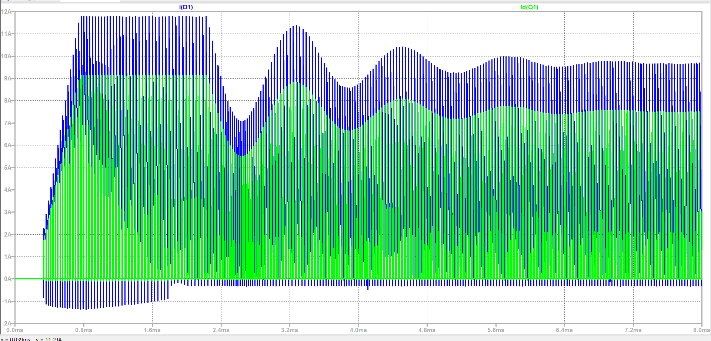

Figure 23 Diode and Switch Currents for the Transient Part

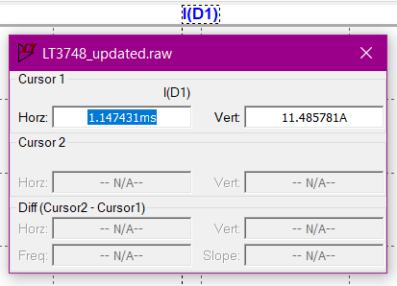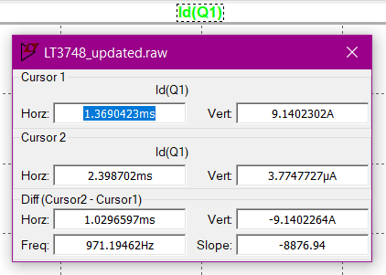

Figure 24 Diode and Switch Current Maxima

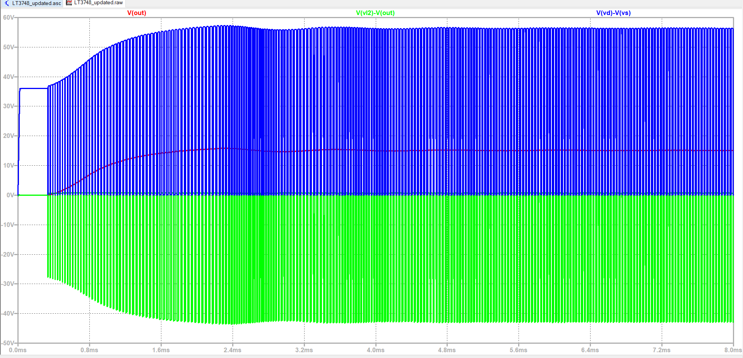

Figure 25 Diode and switch voltages

As seen in Figures 24 and 23, the diode selected must be able to handle at least 12 amperes, and the switch must handle 10 amperes. Also, Figure 25 shows that the switch must endure 60 volts, and the diode must handle at least 55 volts.

For simplicity, the switch is chosen from the lab inventory since the components match with the ratings. IRF540 N-type MOSFET is chosen since it has 100V-27A ratings that can handle our circuit’s needs. For the diode, DS16-01AS-TRL with 100V-16A ratings is chosen.

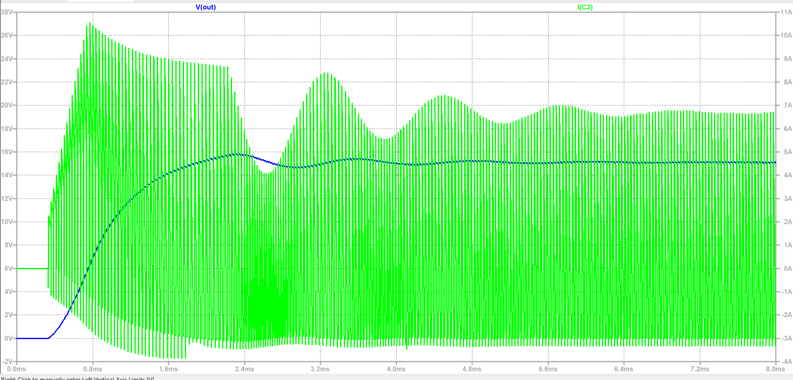

Figure 26 Output capacitor voltage and current for the transient interval

As obtained in Figure 26, the output voltage sees almost 16 volts in the transient time interval, so the output capacitor must bear this voltage. Also, the current seen by this capacitor reaches almost 11 amperes. After checking the most accessible stocks, the **SD1V337M1012MPA** capacitor has been our choice.This capacitor is 330µF and can handle 35V & 0.63A ripple current.

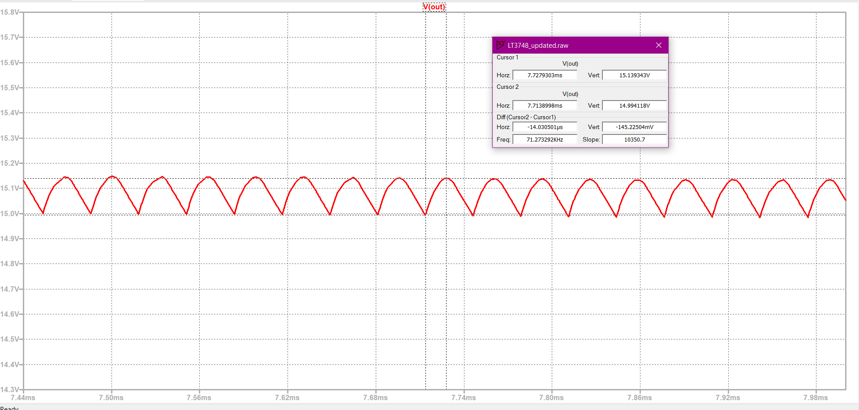

Figure 27 Output Voltage Ripple

As seen in Fig.27, the output ripple is around 0.15 Volts.

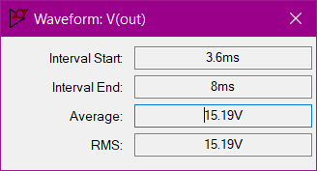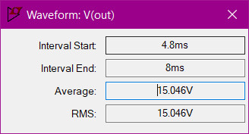

Figure 28 Vout deviation when the input goes from 24V to 48V

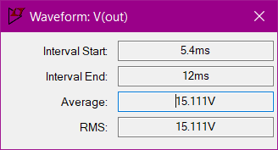

Figure 29 Vout deviation when Io changes from 100% to 10%

Line regulation from our simulation can be seen in Fig.27 as (15.19-15.046) * 100/15.19 = 0.947 % and load regulation can be seen in Figure 28 as (15.111-15.046) * 100/15.111 = 0.43%

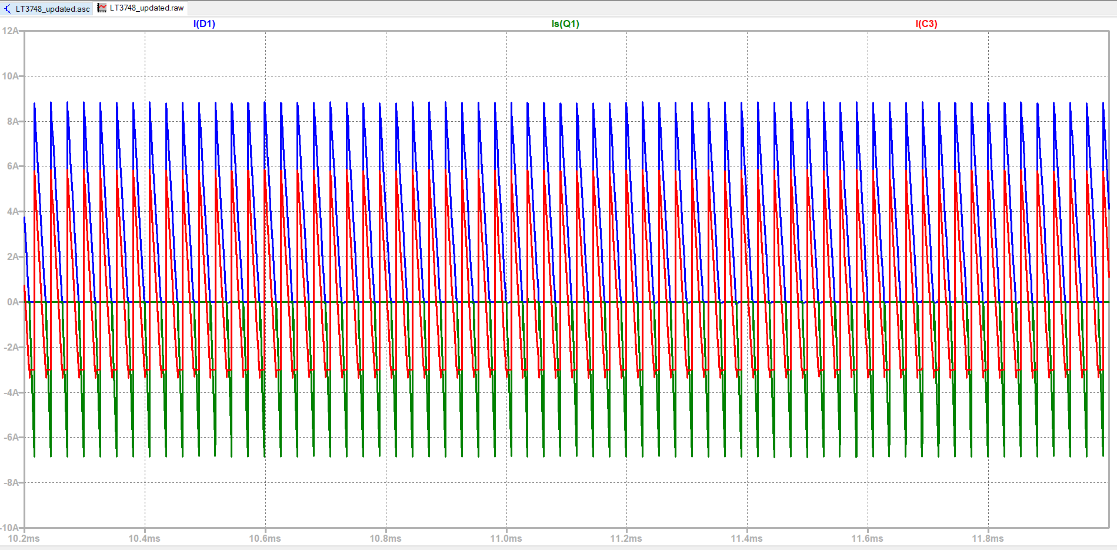

Figure 30 IDiode, IDS and IC at Steady State

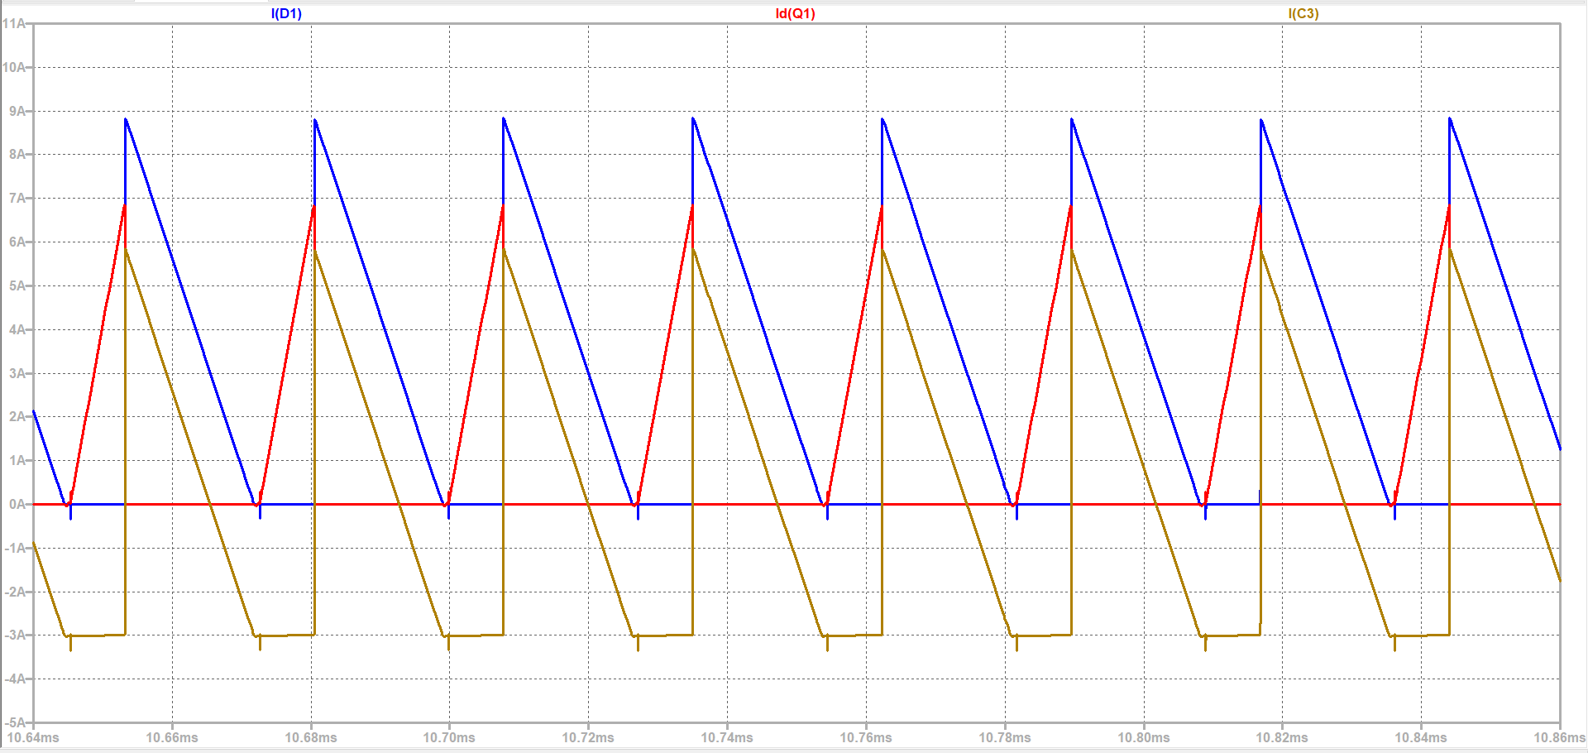

Figure 31 IDiode, IDS and IC waveforms

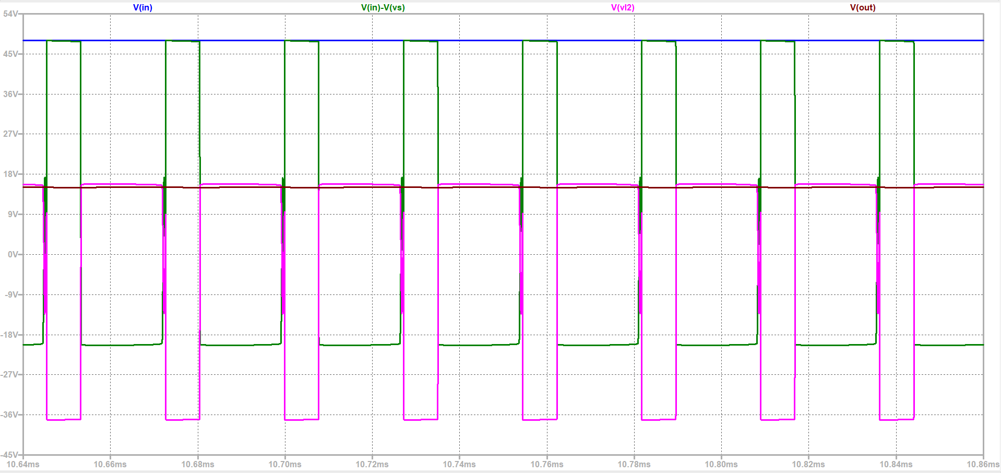

Figure 32 Vin, Vout, VL1 and VL2 voltage waveforms

# IMPLEMENTATION RESULTS

# THERMAL CALCULATIONS

## Mosfet

Pcond = Rds*I2ds(rms) = 0.04*2.152 = 0.185W

Psw = Vin*Io*fsw*(tr+tf) = 48*3*80kHz*(55+57 ns) = 1.3W

Tjunc = Ta + Ploss * Rja = 30+ (1.485*62) = 122.07oC (Ambient temperature is taken as 30oC )

RHA = RJA – RCH – RJC = 62 -1.25

So, the heatsink thermal resistance must be less than 60.75oC/W.

## Diode

Pcond = Vf*If(avg) = 0.64*3.18 = 2.04W

Psw = QR * VRR*fs where QR can be approximated as 0.5*IRM*tRR but since our diode is a Schottky diode, reverse recovery time is very small, thus switching losses can be ignored for now.

Assuming 100oC junction temperature and 30oC ambient,

RHA = (Tj-Ta)/Ploss – RCH – RJC

RHA = 70/2.04 – 0.5 - 1.4 = 32.5

So, the diode’s heatsink thermal resistance must be less than 32.5oC/W

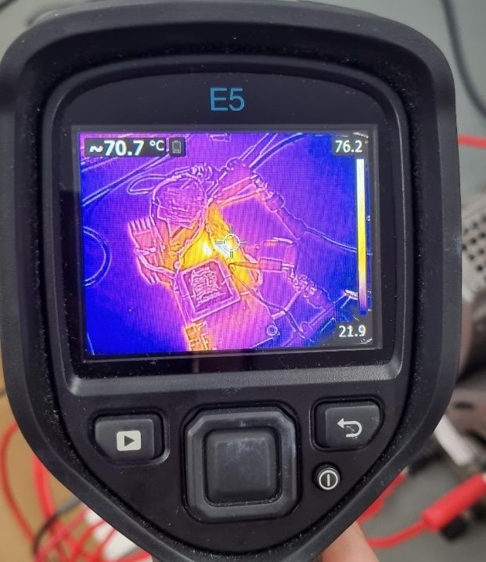

# CONCLUSION

This report focused on the design of an isolated 24-48V to 15V @45W DC-DC converter. The chosen topology of flyback converter is discussed and applicable controller options has been examined. LT3748 isolated flyback controller has been chosen. An appropriate magnetic core has been chosen and magnetic design is done and implemented on the core. Analytical calculations for controller needed components and flyback components are done, and appropriate connections has been made in LTSPICE environment. After observing the ratings of the simulations, appropriate semiconductors and other passive components have been chosen. Thermal calculations for semiconductor devices have been done and design report is finalized.

# REFERENCES

[1] Analog Devices, “100V Isolated Flyback Controller”, LT3748 Datasheet, Feb. 2022

[2] IXYS, “Power Schottky Rectifier”, DS-1601AS Datasheet, 2000

[3] Samwha, Miniature Aluminum Electrolytic Capacitors”, SD1V337M1012MPA Datasheet

[4] Intersil, “33A, 100V, 0.040 Ohm, N-Channel Power MOSFET”, IRF540N Datasheet, March 2000

[5] Analog Devices, “High Voltage Capacitor Charger Controller with Regulation”, LT3751 Datasheet, 2017

[6] Texas Instruments, “2.2MHz Wide Input Nonsynchronous Boost,SEPIC,Flyback Controller with Spread Spectrum”, LM51561 Datasheet, 2020

[7] https://www.we-online.com/

[8] Magnetics, 00K3515E090 Datasheet, Nov. 2021

[9] Magnetics, “Ferrite Cores” (pg.18), 0_44022EC Datasheet, 2009